**Entertainment**

Prepared By:

Name: **Write your Full Name**

Student No.: **Write your Student No.**

Website: https://enter-tainment.netlify.app/

**Google Analytics:**

* **Take a screenshot of google analytic code and paste it here. It should be on your website as well. E.g. Take a screenshot as I mentioned below.**

**Pasted Screenshot:**

<!-- Global site tag (gtag.js) - Google Analytics -->

<script async src="https://www.googletagmanager.com/gtag/js?id=UA-218451469-1"></script>

<script>

window.dataLayer = window.dataLayer || [];

function gtag(){dataLayer.push(arguments);}

gtag('js', new Date());

gtag('config', 'UA-218451469-1');

</script>

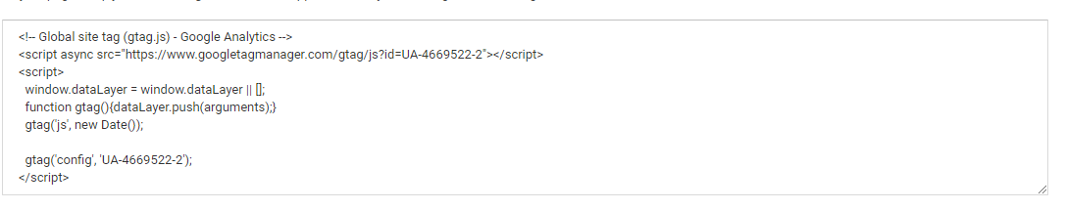

* Take a screenshot of the Realtimetab from Google analytics...

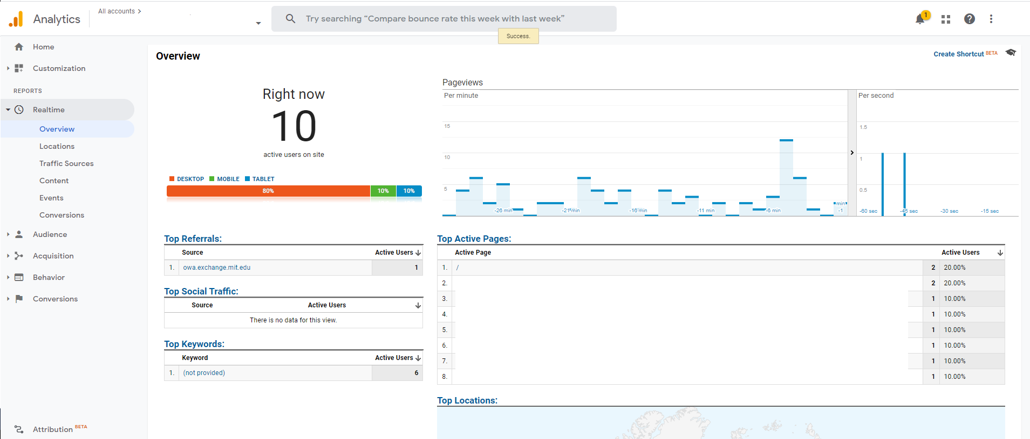

Goal in Google Analytics:

* **Explain what is your goal on the website. How does it work? Take a screenshot of setup and conversions under realtime report.**

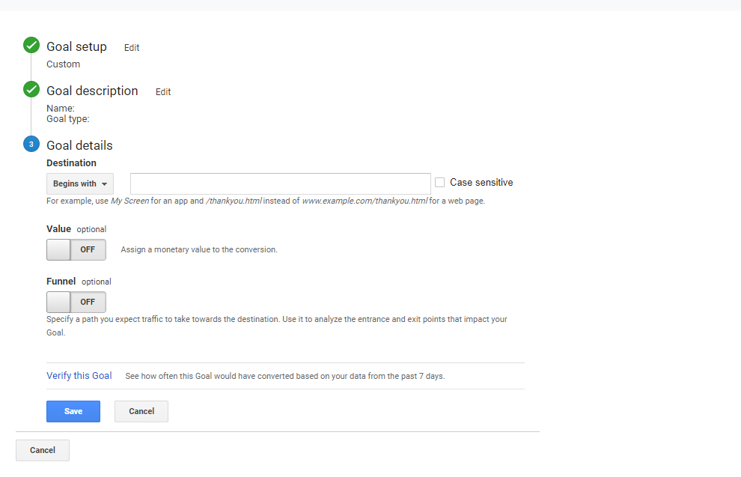

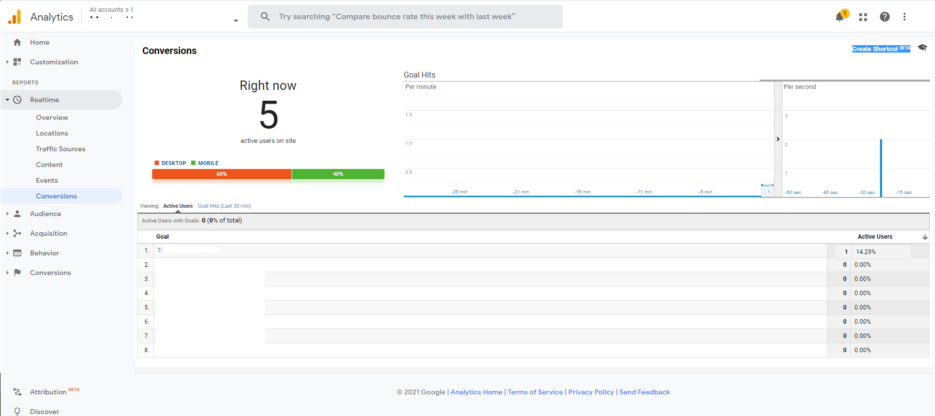

Google Tag Manager:

* **Explain when google tag manager works on your website? Take a screenshot of the setup and event under realtime report.**

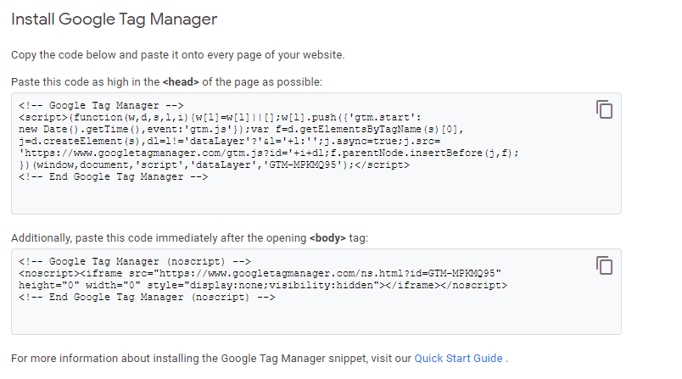

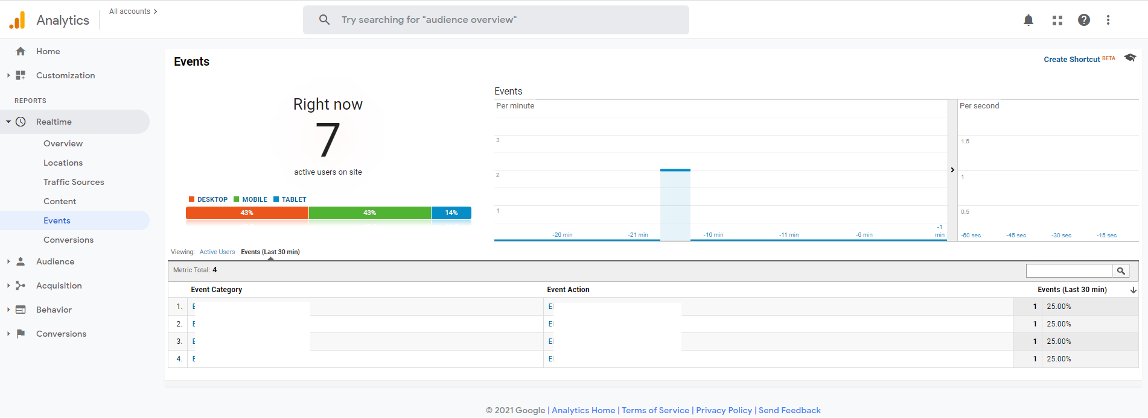

**Keywords Research:**

Note: 2 keywords per page and in your project 7 pages are required so total 14 keywords you have to choose for your website.

|  |  |  |  |
| --- | --- | --- | --- |
| **Keywords** | **Avg. monthly searches** | **Competition** | **Target Page** |
|  |  |  |  |
|  |  |  |  |
|  |  |  |  |
|  |  |  |  |
|  |  |  |  |
|  |  |  |  |
|  |  |  |  |
|  |  |  |  |
|  |  |  |  |
|  |  |  |  |
|  |  |  |  |
|  |  |  |  |
|  |  |  |  |
|  |  |  |  |